Beach-Side RC Oil Cleaning Machine: An Embedded Systems Approach for
Coastal Oil Spill Recovery

System Manual

Submitted by:

Dela Cruz, Denver M.
Delin, Princess Angel G.
Merano, John Lloyd S.
Sombilon, Lyndhel M.
Alejandro, Jhonzen Carl C.
Escuterio, Kazz Denielle
Magararu, Joanne
Malabha, Jay-ar
Magno, Carlo Jose

May, 2026
Table Of Contents
Introduction 3
System Overview 3
Main Components 4
Safety Guidelines 5
Power System Overview 5
Initial Setup Procedure 6
Connecting the Machine to Wi-Fi 6
Identifying the IP Address 7
Accessing the Web Controller 8
Web Controller Interface Guide 8
Operating the Machine 10
Emergency Stop Procedure 11
Charging System and Solar Setup 11
Maintenance Procedures 11
Troubleshooting and Debugging Guide 12
Wiring and Electronics Notes 15
Recommended Startup and Shutdown Sequence 16
Storage Guidelines 16
Technical Specifications 17
Developer Notes 17

Introduction
The Beach-Side RC Oil Cleaning Machine is a remote-controlled oil skimming and collection machine designed for cleaning oil-contaminated water surfaces near shorelines, beaches, and shallow waters. The machine uses a web-based control system powered by an ESP32 microcontroller and can be operated through any smartphone, tablet, or laptop connected to the same Wi-Fi network.
The machine includes:
- Dual mobility motors for movement
- Drum skimmer system for oil collection
- Diaphragm pump for oil transfer
- Linear actuator for boom arm positioning
- Web-based remote-control interface
- Solar charging support
- Battery-powered operation

System Overview
The system consists of four major sections:
A. Mobility System
Responsible for machine movement using two 12V MY6812 120W brush motors controlled by BTS7960 motor drivers.
B. Oil Collection System
Consists of:
- Drum skimmer motor
- Drum skimmer assembly
- Diaphragm pump
- Oil collection container
C. Boom Arm and Actuator System
Uses a linear actuator to raise or lower the boom/skimmer assembly.
D. Control and Electronics System
Consists of:
- ESP32 microcontroller
- WiFi web controller
- MOSFET modules
- BTS7960 motor drivers
- Fuse block
- Buck converter
- Battery and solar charging system

Main Components
Mechanical Components
- Steel or aluminum chassis frame
- Drum skimmer assembly
- Boom arm assembly
- Linear actuator
- Front swivel caster wheel
- Rear drive wheels
- Chain and sprocket system
Electrical Components
- ESP32 microcontroller
- 12V 25Ah battery
- 50W solar panel
- 30A solar charge controller (SCC)
- 50A 2-pole circuit breaker
- 10A 2-pole circuit breaker
- 12-way marine fuse block
- BTS7960 motor drivers
- MOSFET modules
- 5A buck converter
Mobility Motors
- MY6812 12V 120W brush motors
Auxiliary Devices
- 12V diaphragm pump
- 12V JGB37 drum motor

Safety Guidelines
General Safety
- Never operate the machine without checking all wiring connections.
- Keep hands away from moving chains, sprockets, and drum assemblies.
- Do not expose electronics directly to seawater.
- Always inspect wires for damage before operation.
- Disconnect battery power before maintenance.
Electrical Safety
- Ensure proper fuse ratings are installed.
- Never short positive and negative terminals.
- Keep the battery dry and ventilated.
- Use only properly rated wires.
Water Operation Safety
- Do not operate in deep water beyond machine capability.
- Avoid strong waves or currents.
- Ensure flotation stability before operation.

Power System Overview
Solar Charging Connection
The charging system is connected as follows:
50W Solar Panel → 10A Circuit Breaker → 30A SCC → 50A Circuit Breaker → 12V Battery
Main Power Distribution
The battery connects directly to:
- Marine fuse block positive terminal
- Marine fuse block negative terminal
- 50A breaker
All system components receive power through the marine fuse block.
Fuse Ratings
Component | Fuse Rating
Left Mobility Motor | 20A
Right Mobility Motor | 20A
Linear Actuator | 20A
Diaphragm Pump | 15A
Drum Motor | 5A
Buck Converter | 5A

Initial Setup Procedure
Step 1: Inspect the Machine
Before powering on:
- Check all wiring connections
- Check battery voltage
- Ensure fuses are installed
- Ensure chains and sprockets are aligned
- Verify wheels rotate properly
Step 2: Turn ON the Main Breaker
Switch ON:
- 50A battery breaker
- 10A solar breaker if charging is needed
Step 3: Power the ESP32
The ESP32 receives 5V power from the buck converter.
After power-up:
- ESP32 will automatically initialize
- WiFi network will activate
- Web server will start

Connecting the Machine to Wi-Fi
The ESP32 creates or connects to a Wi-Fi network depending on the programmed configuration.
Option A: ESP32 Access Point Mode
If configured as Access Point:
- Open phone Wi-Fi settings
- Look for the machine Wi-Fi name (SSID)
- Connect using the configured password
- Wait until connected
Example:
- Wi-Fi Name: Galaxy A52s 5GB1D0
- Password: upui9397
Option B: Home Router Mode
If connected to a router:
- Connect phone to same WiFi network
- Power on machine
- Find machine IP address
- Open browser and enter IP address
Note: The Wi-Fi SSID should be modified to “Galaxy A52s 5GB1D0” and Password to “upui9397”.

Identifying the IP Address
Method 1: Serial Monitor (Recommended)
Connect ESP32 to a laptop.
Open Arduino Serial Monitor.
The ESP32 will display:
IP Address: 192.168.1.100
Method 2: Router Device List
Open router admin page.
Check connected devices.
Look for:
- ESP32
- OilCleaner
- Unknown device
Example IP:
- 192.168.1.100

Accessing the Web Controller
Procedure
- Open any browser
- Type the IP address into the address bar
- Press Enter
Example:
http://192.168.1.100
The controller dashboard will load.

Web Controller Interface Guide
The web controller interface allows complete remote operation of the machine.
A. Mobility Control Joystick
The large circular joystick controls movement.
Functions
Direction | Action
Forward | Move forward
Backward | Reverse
Left | Turn left
Right | Turn right
Center | Stop
B. Motor Speed Indicators
The interface displays:
- Left motor speed percentage
- Right motor speed percentage
Example:
- LEFT: 60%
- RIGHT: 60%
C. Pump Control
Controls the diaphragm pump.
Button Functions
Button | Function
Power Button ON | Start pump
Power Button OFF | Stop pump
D. Auxiliary Motor Control
Controls the drum skimmer motor.
Button Functions
Button | Function
Power Button ON | Start drum motor
Power Button OFF | Stop drum motor
E. Linear Actuator Controls
Controls boom arm movement.

Button | Function
Up Arrow | Extend actuator
Down Arrow | Retract actuator
F. Emergency Stop
The red EMERGENCY STOP button immediately disables:
- Mobility motors
- Pump
- Drum motor
- Linear actuator
Use during unsafe operation.
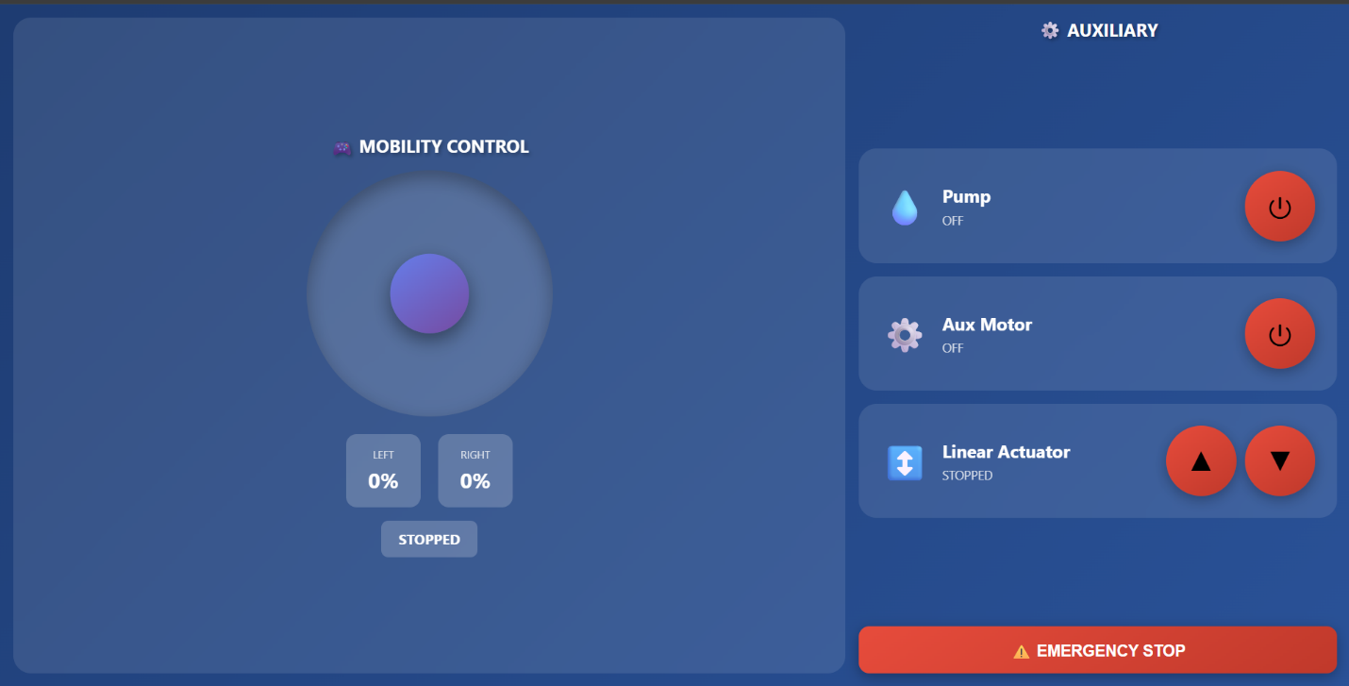

Operating the Machine
Starting Operation
- Power ON system
- Connect to web controller
- Test motor movement slowly
- Lower boom arm using actuator
- Turn ON drum motor
- Turn ON pump
- Begin forward movement
Oil Collection Process
- Drum rotates and attracts oil
- Oil is scraped into collection tray
- Pump transfers oil into storage container
Steering Tips
- Use slow movements in shallow water
- Avoid sudden turns
- Reduce speed during skimming

Emergency Stop Procedure
If unsafe behavior occurs:
- Press EMERGENCY STOP button immediately
- Turn OFF main breaker if needed
- Disconnect battery during maintenance
Possible emergency situations:
- Motor overheating
- Wire smoke
- Water entering electronics
- Mechanical jam
- Loss of control

Charging System and Solar Setup
Solar Charging Procedure
- Place solar panel under sunlight
- Turn ON 10A solar breaker
- SCC will regulate charging automatically
SCC Indicators
Indicator | Meaning
Charging Icon | Solar charging active
Battery Icon | Battery connected
Low Voltage | Battery low
Important Notes
- Never connect SCC directly to panel before battery
- Always connect battery first
- Use proper wire sizes

Maintenance Procedures
Daily Inspection
Check:
- Battery voltage
- Fuse condition
- Motor temperature
- Wire connections
- Chain tension
- Pump hoses
Weekly Maintenance
- Clean drum skimmer
- Remove oil residue
- Inspect sprockets
- Tighten bolts
- Inspect actuator mounting
Monthly Maintenance
- Check bearings
- Reapply grease if needed
- Inspect waterproof seals
- Test all breakers

Troubleshooting and Debugging Guide
A. ESP32 Does Not Power ON
Possible Causes
- Buck converter failure
- No battery power
- Loose wiring
- Fuse blown
Solutions
- Check 5V output from buck converter
- Check battery voltage
- Replace fuse
- Verify GND and 5V wiring

B. Cannot Access Web Controller
Possible Causes
- Wrong IP address
- WiFi not connected
- ESP32 frozen
Solutions
- Restart ESP32
- Reconnect to WiFi
- Check Serial Monitor IP address
- Ensure same network connection

C. Mobility Motors Not Moving
Possible Causes
- BTS7960 wiring issue
- Blown fuse
- Low battery
- Loose motor wires
Solutions
- Check BTS7960 B+ and B-
- Check RPWM and LPWM GPIO connections
- Verify fuse continuity
- Test battery voltage

D. Pump Not Working
Possible Causes
- MOSFET wiring issue
- Pump fuse blown
- Pump jammed
Solutions
- Check MOSFET IN+ and IN-
- Check GPIO control signal
- Replace fuse
- Test pump directly with battery

E. Drum Motor Not Spinning
Possible Causes
- MOSFET issue
- Motor jam
- Broken shaft coupling
Solutions
- Check MOSFET output voltage
- Inspect drum shaft
- Test motor independently

F. Linear Actuator Not Moving
Possible Causes
- BTS7960 issue
- Mechanical obstruction
- Actuator overload
Solutions
- Check actuator fuse
- Check BTS7960 enable pins
- Inspect actuator mounting
- Remove obstruction

G. System Randomly Restarts
Possible Causes
- Voltage drop
- Weak battery
- Shared power noise
Solutions
- Add capacitor near ESP32
- Check battery condition
- Separate high-current wiring from signal wires

H. Motors Move in Wrong Direction
Solution
Swap motor terminal polarity:
- Reverse M+ and M-
I. Overheating Wires
Possible Causes
- Wire too small
- Loose terminal
- Excess current
Solutions
- Use thicker wire
- Tighten connections
- Reduce load

Wiring and Electronics Notes
Important Wiring Rules
- Keep signal wires away from motor wires
- Use proper fuse sizes
- Secure all terminals tightly
- Waterproof exposed connections

Wire Recommendations
Application | Recommended Wire
Battery Main Line | 8-12AWG
Mobility Motors | 16AWG
Pump | 18AWG
Drum Motor | 18AWG
ESP32 | 20–22AWG
Signal Wires | 22AWG

Recommended Startup and Shutdown Sequence
Startup
- Check machine
- Turn ON breakers
- Wait for ESP32 boot
- Connect to controller
- Test controls
- Begin operation
Shutdown
- Stop movement
- Turn OFF pump
- Turn OFF drum motor
- Retract actuator
- Turn OFF breakers
- Disconnect battery if storing

Storage Guidelines
- Store in dry location
- Disconnect battery during long storage
- Recharge battery monthly
- Cover electronics from moisture
- Clean oil residues after use

Technical Specifications
Component | Specification
Battery | 12V 25Ah Gel Battery
Solar Panel | 50W
SCC | 30A PWM/MPPT
Mobility Motors | MY6812 12V 120W
Drum Motor | JGB37 12V 35RPM
Pump | 12V Diaphragm Pump
Controller | ESP32
Main Breaker | 50A
Solar Breaker | 10A

Developer Notes
GPIO Assignment

Mobility Driver #1
Function | GPIO
RPWM1 | 25
LPWM1 | 26
R_EN1 | 27
L_EN1 | 13

Mobility Driver #2
Function | GPIO
RPWM2 | 32
LPWM2 | 33
R_EN2 | 18
L_EN2 | 19
Linear Actuator Driver
Function | GPIO
RPWM3 | 23
LPWM3 | 22
R_EN3 | 21
L_EN3 | 4
MOSFET Outputs
Device | GPIO
Pump | 14
Drum Motor | 12

